 | PYROTECH WORKSPACE SOLUTIONS PVT. LTD. | DOC. NO.: IMS-02-01-03-05
 | HR Department | PAGE NO.: 04
 |  | ISSUE DATE: 07-02-2022
 | Skill Matrix Procedure | REV. NO.: 00
 |  | STANDARD: QMS, EMS, OHMS

- Purpose:
We at PWSPL highly encourage skill enhancement of our employees. Our Skills Matrix is a visual instrument that allows managers and top management to observe, analyze, and map out the various skills and competencies of their team members. This matrix is essentially used to find out the required vs available skill-set of each employee of working departments as well as find out the gaps in certain types of skill set and help assign job responsibilities as per the available skill set of a certain individual.
- Creating a Skill Matrix:
A skills matrix is a tool used in the workplace to identify the skills that a team will need to complete their job role successfully. This department wise matrix shows the skills that team members already possess as well as skills that need to be developed for performing departmental task operations. By listing out the skills and competencies that a team has and/or is working on, managers and team members can clearly see what the team has to offer and how can it be improved.
- Filling & Reviewing a Skill Matrix:
First of all, the Team Leader/Manager needs to identify the list of skill sets required as per his/her department’s smooth functionality. These set of skills are then divided into two parts: Critical Skills and Non-Critical Skills.
A Critical Skill is a Skill which has a direct impact on the FIT FORM & FUNCTION of the product + Output of the process hugely depending on human skill.
Then each team member is given a typical rating (between 0 level to 4 level) by their Process Owner depending on that person’s proficiency in the mentioned skill as well as their interest in learning and/or developing a particular skill. This allows HOD's to effectively distribute tasks to team members who both want to use their skills for the task and who can complete the task in a successful manner.
The given skills are segregated in two categories:
- Technical Skills (directly related to work)
- Generic Skills (apply across a variety of jobs and life contexts)
Once the skill matrix for the entire department is completed, the gaps identified are informed to the HR Department via a TNI Document (Training Needs Identification IMS-02-01-03-41) so that HR team can add those skills as a training topic in their annual Training Calendar (IMS-02-01-03-42)
These skill matrices are then reviewed and updated twice a year as per the current trainings provided and the improvement shown by the individual.
HR Department shall take the responsibility of maintaining the half yearly records of filled skill matrices of each department. Whereas, all the HOD’s or Process Owners shall take the responsibility of evaluating and training their team members on the core-technical skills, the skill score of their team members are then revised as per Training Assessment and updated in the Skill Matrix along with the help of HR.

- For reviewing the skill matrix below given criteria need to be followed:
Sl. No | Criteria | Remarks
1 | CRITICAL SKILL:  The Skill which has a direct impact on the FIT FORM & FUNCTION of the product + Output of the process hugely depending on human skill | This is how critical skills will be identified
2 | Review frequency: Once in 06 months or New skills identified /Required or need basis; whichever is earlier
3 | Critical Skills: Training to be initiated when the variance drops <2 | Variance cell turns RED when goes below 2
4 | Other skills: Training to be initiated when the variance drops <1 | Variance cell turns RED when goes below 1
5 | Training records to be maintained for upgrade in skill (each level upgrade) | From Level 2 to Level 3  & From Level 3 to Level 4
6 | On the job training evaluation to be completed before upgrading skill for any  Evaluation of training through theoretical 7 practical assessment
7 | Manpower required based on the Load & demand for next 3-6 months will be considered as required manpower while reviewing skill matrix
8 | Any new skill required will be reviewed based on contract review outcome for any new projects.
9 | If there are no Level 4/expert then level 3 person shall be upgraded by external trainers/Internal team leaders with adequate knowledge.

- For Upgrading Skill Matrix:
All upgrades in skills from 2 to 3 & 3 to 4 needs to be documents for evaluation of skills (Theory + practical evaluation). Need some evidences on that to show the advancement is effective & the member is skilled to handled it independently.
1. Identification of Skill Variance with Trainees Name
2. Identification of Trainer (With Skill Level 4 above) else an external trainer
3. Training will be included in the Annual Training Calendar under technical trainings with practical and theoretical evaluation & supporting documents of level up-gradation.
4. Any new skill required should be added on request of concerned HOD through proper communication.
5. The control on accessibility for upgrading levels in skill matrix lies with HR Department. The up gradation will only be considered if it complies fully to clause 3.
6. All new team members joined in a department shall by-default be at 01 rating and at the time of completion of their Probation Period, their actual Skill Scores shall be assigned/evaluated.

- Understanding the Skill Matrix Format:
Below are the 15 main fields which are explained below on how to understand the meaning of each field and what to fill in the said field of our Skill Matrix:

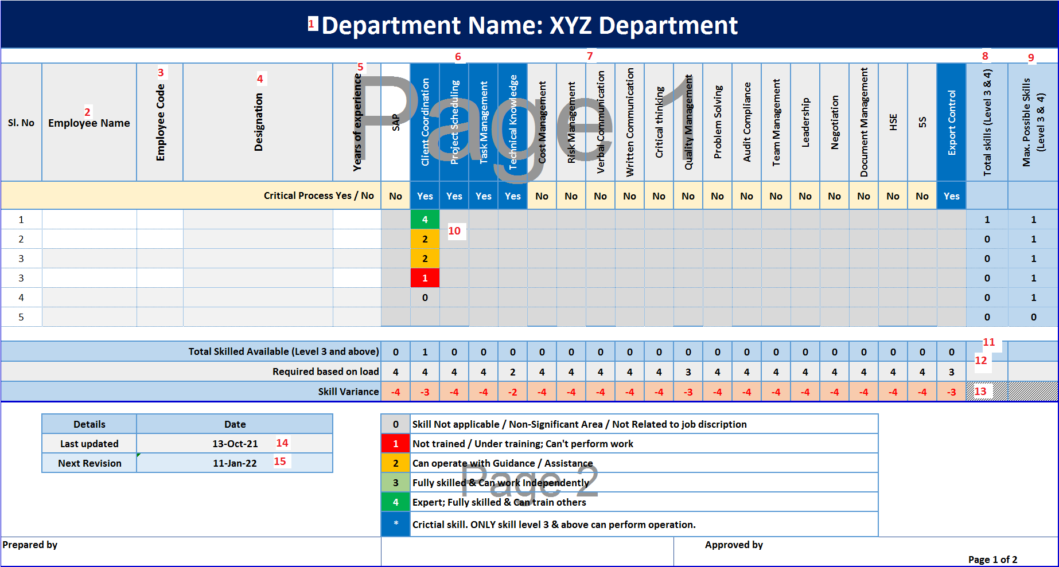

- Department Name: Write down your department’s name here.
- Employee Name: Write down the list of all employees in your department.
- Employee Code: Write down the Company Issued Employee Codes of each employee.
- Designation: Write down their assigned designation.
- Years of Experience: Write down their total years of experience they hold till date.
- Critical Skills: The Skill which has a direct impact on the FIT FORM & FUNCTION of the product + Output of the process hugely depending on human skill.
- Non-Critical/Generic Skills: Other generic/non-technical skills which are required for smooth operations.
- Total Skill Level: This shows the automatic sum of number of 3 & 4 rated skills that particular employee has, i.e. showing the overall employee scoring in terms of efficiency.
- Max. Possible Skills: This shows the automatic sum of total number of applicable skills sets for that particular employee, i.e. maximum available score.
- Skill Scoring: Each employee is scored as per below scoring:
  - 0 = Skill Not applicable / Non-Significant Area / Not Related to job description
  - 1 = Not trained / Under training; Can't perform work
  - 2 = Can operate with Guidance / Assistance
  - 3 = Fully skilled & Can work Independently
  - 4 = Expert; Fully skilled & Can train others
  - * = Critical skill. ONLY skill level 3 & above can perform operation.
- Total Skilled Available: This shows the automatic sum of total number of employees who have scored above 3 in each cell.
- Required based on load: In this cell, you need to write down the total number of employees required in your team of that particular skill as per the overall annual sales/demand forecast.
- Skill Variance: This shows the automatic difference or gap in each applicable skill which needs to be covered by either training or recruiting more employees. (Refer point number 3 & 4 in above mentioned table in Section 4)
- Last Updated Date: Write down the date on which you have done your first/last skill assessment of your department.
- Next Revision Date: Write down the date in next 6 months of your last assessment and set an automatic email reminder to help you get a reminder that your department’s skill matrix needs to be revised as per annual performance and trainings received by your team members.

Note 1: Each improvement in skill score must be recorded via a written assessment on that particular skill (Critical/Technical skills/Non-Technical/Generic Skills).

***************

